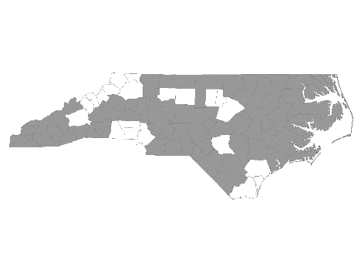


Davie-Iredell-Stokes-Surry-Yadkin (DISSY) Regional Committee
Meeting Minutes
Tuesday March 20, 2018 – 9:30 am
Location: Partners BHC, 200 Elkin Business Park Dr. Elkin, N.C. 28621

Those present were:

Kevin Hege – DISSY Regional Committee lead
Brian Smith - SHAHC
Christy Champion-Fritz - The Ark
Debbie Owen - Fifth Street Ministries, DISSY Rapid Rehousing Coordinator
Bonnie Harper - GHCCM
Janet Carlton - Goodwill
Diane Dunn - Salvation Army GSO
Maxine Manley - Salvation Army SSVF
Debbie Hunter - Workfirst Surry Co.
Donna Martin - Stokes DSS (on conference)
Julie Pulman - Community Care Iredell/ Alexander (on conference)
Mollie Thompkins - Partners BH

Kevin called the meeting to order and welcomed everyone.

He made a motion to accept the minutes from February13, 2018. The motion was then approved by common consent.

We then received updates from the following agencies that provide services to the homeless within the five county region:

- Diakonos, Inc. dba Fifth Street Ministries -The shelter served 116 single women and men, and 9 families (10 children, 12 adults) this period. They are still accepting referrals. The Veteran’s Transitional Housing Program served 5 veterans in the house, and 4 at Fifth Street. All services offered by Fifth Street Ministries are available to anyone within the five county region.
The new shelter, HOME of Mooresville, opened the end of December. They serve single women and children from Mooresville. They are currently full with 3 families.

- DISSY Rapid Rehousing -There are currently 4 families in housing. Referrals are currently being accepted. Please send in the VISPDAT before filling out the full application. Going forward, Rapid Re-Housing will be open to individuals on a case by case basis.

- SHAHC - There is still a two bedroom available. They hope to start partnering with Habitat in the near future. Their Transitional program is for families up to 2 years. The family is charged 30% of their income while in the program. They also offer permanent supportive housing.

- The Ark - Currently has 3 children and 8 adults. Will have 17 total by the end of this week. 2 family rooms and 6 singles single slots are currently available.

- Goodwill - Goodwill is holding a job fair Wednesday, March 28 from 10:00 - 2:00.
There are funds available for rent, deposits, and utilities for Veterans who are enrolled in the Goodwill program.

- GHCCM - Will have an opening for permanent supportive housing in Catawba Co.

- Community Care - Provides case management for Medicaid recipients in Iredell and Alexander Co. Interested in information on housing resources for clients.

- Workfirst Surry Co. - Provides employment services to families with at least one child under age 18. Services include job search, transportation, childcare, and other referrals as needed. Currently working Food Stamp recipients with the 20 hr. volunteer work requirement.

- Salvation Army SSVF - Has preventive funds. In need of Veterans looking for housing options.

- Partners BH - There are targeted units currently available. Must have clean background and permanent income. (A job does not qualify)

The next meeting will be Tuesday, April 10, 2018 at 10:00 A.M. at Partners BHC,
Elkin, NC 28621.

With no further business, the meeting was adjourned.

Respectfully submitted, Deborah W. Owen

Coordinated Assessment Sub Committee
The committee did not meet.

