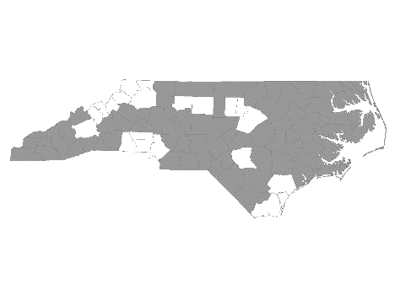


Davie-Iredell-Stokes-Surry-Yadkin (DISSY) Regional Committee
Meeting Minutes
Tuesday June 12, 2018 - 10:00 am
Location: Partners BHC, 200 Elkin Business Park Dr. Elkin, N.C. 28621

Those present were:

Kevin Hege - DISSY Regional Committee lead/ Surry Co. Veteran’s Council
Alyson Snow - The Ark
Mary Boyles (On conference)
Debbie Owen - Fifth Street Ministries, DISSY Rapid Rehousing Coordinator
Bonnie Harper - GHCCM
Elisha Harris - YVEDDI
Diane Dunn - Salvation Army GSO
Maxine Manley - Salvation Army SSVF
Denadia Nappier - Salvation Army - WS
Christien Armour - Goodwill SSVF
Sandra Johnson - Adult Services Surry
Donna Martin – DSS Stokes (On conference)
Teena Willis - Partners BH (On conference)
Molly Thompkins – Partners
Janet Carlton – Goodwill
Sandra Johnson – DSS Surry
Lucas Vrbsky – Veteran’s Health Salisbury

Kevin called the meeting to order and welcomed everyone.

He made a motion to accept the minutes from May 8, 2018. Janet Carlton seconded the motion and it was approved.

We then received updates from the following agencies that provide services to the homeless within the five county region:

- Diakonos, Inc. dba Fifth Street Ministries - Fifth Street served 114 single individuals and 8 families. They are still accepting referrals. My Sister’s House, battered women’s shelter, served 17 women and 19 children. The Veteran’s Transitional Housing Program served 5 veterans in the house. All services offered by Fifth Street Ministries are available to anyone within the five county region.
HOME of Mooresville currently has two families. They serve single women and children from Mooresville. They have an opening for one family.

- DISSY Rapid Rehousing -There are currently 5 families in housing. One family has been accepted and is looking for housing. Referrals are currently being accepted. Please send in the VISPDAT before filling out the full application. Going forward, Rapid Re-Housing will be open to individuals on a case by case basis.

- The Ark - Currently 6 children and 16 adults. They have 2 single slot openings. (top bunk) They serve families and single women who are not victims of domestic violence.

- Shepherds’s House - Averaged 15 clients daily in May. Turned away 32 due to lack of space. Currently working to get rezoning for a new shelter behind the Shepherd’s House.

- GHCCM - Encouraging clients to apply for section 8. Trying to network with Surry Co. Housing Authority.

- Goodwill CC Elkin - Offering employability skills through Surry Co. Community College June 19, July 3 & 17 from 9:30- noon. Will offer mammogram screenings through Novant Health June 19th.

- Surry Co. DSS - Still giving referrals/ doing intakes weekly. Still needs resources for housing, including deposits. Currently using SHAHC as one resource and is adding other resources as they become available.

- Goodwill/SSVF - Has preventive and Rapid Re-Housing funds and current openings. Continuing to provide outreach services to Vets.

- Stokes DSS - Had meeting concerning PIT count for summer.

- YVEDDI - In process of closing out fiscal year. Addresses barriers to obtaining increased income by providing assistance/ referrals for childcare, education, transportation, etc.

- Partners - Discussed coordinated entry process and need for more functionality. Also, county funds available for those receiving mental health services. Can be used for a variety of services including car repair, utilities, and hotel stays.

- Veteran’s Health Services Salisbury - Serves homeless Vets including prison visitation.

- Kevin - Currently working on a homeless shelter at the site of the old Grace Clinic.
Discussed Steering Committee short summary, upcoming webinars, and coordinated assessment
process.

The next meeting will be Tuesday, July 10, 2018 at 10:00 A.M. at Partners BHC,
Elkin, NC 28621.

With no further business, the meeting was adjourned.

Respectfully submitted, Deborah W. Owen

